UNDERSTANDING INTELLECTUAL ASSETS (IAs)

(This Guide draws upon mSME experiences under a European Union funded [Project Reference 53611] business support initiative on Intellectual Property, IP Wales®. Disclaimer: The information contained in this guide is not meant as a substitute for professional legal advice. Its main purpose is limited to providing basic information on the subject matter).

© Andrew Beale (2010), all rights reserved
Intellectual Assets Crown
Every business holds Intellectual Assets whether they appreciate it or not. In the past firms have been slow to appreciate these assets, hence their description as the ‘hidden assets of a business’. In a recent survey of European firms published by the Economist Intelligence Unit 35% of respondents thought the use of IAs to be ‘critical’ or ‘important’ to their company’s business model today, growing to
53% who thought it would become ‘critical’ or ‘important’ to their company’s business model within the next two years. IAs are fast becoming recognised as the potential ‘Crown jewels’ of a knowledge economy business, enabling them to differentiate their services and products from competitors within the commercial market place. The challenge facing firms today lies in the development of individual IAs plans for each service or product offered by the business and the integration of a new or improved IAs Strategy within the overall Business Plan.

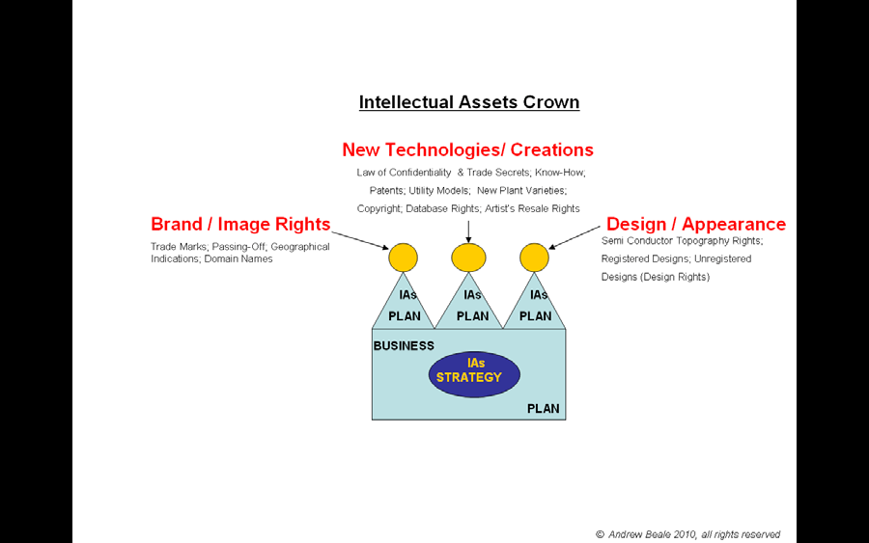

IAs
So what are these Intellectual Assets and how should they be used by
companies as part of their commercial model for doing business? The Intellectual
Assets of your business consist of the ‘Intellectual Property’ and ‘know-how’
(non-patented practical information resulting from experience and testing) held by your firm.

‘Intellectual Property Rights’ are the legal rights given to your business to enable you to block or control the use of your Intellectual Assets. These legal rights are

© Andrew Beale (2010), all rights reserved
either monopolistic in nature (requiring registration for their acquisition) or otherwise occur automatically as part of ordinary business practice, providing you with more limited exclusive rights over your Intellectual Assets.

In addition to its Intellectual Property your business might also hold trade secrets and other types of ‘undisclosed information’ (committed to written form or otherwise held as tacit knowledge) which have a commercial value.

IP Wales finding:

• Because it does not represent formal IP as such mSMEs often underestimate the commercial value of their know-how and fail to document it.
• Moreover mSMEs often overvalue the commercial importance of their patents in the biased belief that their invention represents a major technical advance – the degree of technical advance is best established via an in-depth prior art review and market analysis survey.

TRIPS
Whereas today’s global market place dictates that to only compete nationally is not to be competitive, all intellectual assets are territorial in nature. The World Trade Organization’s Agreement on Trade-Related Aspects of Intellectual Property Rights (TRIPS) recognises the following types of assets as potentially relating to your business, which can and are typically used in combination with each other:-

• Copyright & neighbouring/related rights
• Industrial Property
o Trademarks, including service marks
o Geographical indications
o Patents
o Industrial designs
o Undisclosed information, including trade secrets
• Layout-designs (topographies) of integrated circuits

Copyright & neighbouring/related rights:
Copyright law grants the owner or copyright holder of a created original work exclusive ‘economic rights’ to reproduce copies of the work, distribute copies of the work to the public, rent copies of the work, make derivative works (i.e. adaptations or translations of the protected work), publicly perform and communicate the work to the public, receive a percentage of the sale price if the work is resold, make the work available on the internet etc. Copyright also recognises ‘moral rights’ of which your business needs to be aware. These are designed to protect an author’s (i.e. including an employee’s) reputation and integrity but can be waived by the author under written agreement. Some countries, like the United States of America and the United Kingdom, incorporate

© Andrew Beale (2010), all rights reserved
the rights of performers, producers of sound recordings and broadcasting organizations under copyright law. Other countries, such as Germany and France, protect these rights under a separate category called “neighbouring rights”. Copyright covers not only passive works, such as text, sounds, graphics, photographs, music, animations, videos and software but also active works, such as computer programs. Some jurisdictions, such as the European Union, also provide for the protection of database rights.

Trademarks, including service marks:
A distinctive sign capable of distinguishing your services or products from those of your competitors in the commercial market place can be registered as a trademark. Examples of such signs include words, letters, numerals, drawings, pictures, shapes, colours, logotypes, labels etc.. This Intellectual Asset can be marketed as a business brand within the market place. Some countries allow advertising slogans to be considered as trademarks. In order to prevent the importation of counterfeit trademark goods measures may be available for trademark owners to undertake with national custom authorities. Some jurisdictions also provide legal protection for the use of a sign which has not been registered in order to prevent an unscrupulous firm from passing themselves off as another within the commercial market place.

Geographical indications:
Your business may reside in a geographic region or place, the name of which conveys to consumers not only where the product originated but also gives an indication of special characteristics to be attributed to the product which are the result of the product’s origins. Well-known cited examples include “Champagne”,
“Scotch”, “Tequila” and “Roquefort” cheese. Whereas this form of Intellectual
Property can also apply to other market areas it has particular application to the food and drink industries.

Patents:
Your business can use Patent Law to protect its inventions providing it can demonstrate that the invention is new, involves an inventive step, is capable of industrial application and is not comprised of excluded subject matter. In most countries patents are granted to the first person to file the invention. A notable exception is the United States of America where the first person to invent takes priority. In some countries incremental inventions or small adaptations to existing products can be protected via “Utility Models” (also known as short term patents, petty patents or innovation patents). Particular concerns can arise with the patenting of computer software. In most countries the object and source code of computer programs can be protected by copyright. In some countries, such as the United States of America, mathematical algorithms (the basis of improved functionality of computer software) can be patent protected while in other countries such inventions are explicitly excluded or at least required to demonstrate a technical contribution to the state of the art.

© Andrew Beale (2010), all rights reserved
Industrial designs:
Product appearance and the “get-up” of products may be protected by Industrial Design Law. Whereas other aspects of intellectual property law may apply to the technical or functional aspects of the product, the ornamental or aesthetic aspects of the finished product may of itself be capable of protection under law. Industrial design is relevant to a wide variety of products from industry, fashion and sometimes handicrafts.

Undisclosed Information, including trade secrets:
These assets may be protected against breaches of confidence and other acts contrary to honest commercial practices. In a commercial context the value of information is usually maximized when it is denied to business competitors. The law in this area addresses the issue of control over access to commercial information but in order to provide for any legal protection an obligation is likely to be placed on your business to have taken reasonable steps to keep the information confidential. Consider for example affidavit evidence submitted by a senior vice-president and general counsel for Coca-Cola in a court case, that the written version of the secret formula for Coca-Cola (a.k.a. “Merchandise 7X”) is kept in a security vault at the Trust Company Bank in Atlanta, and the vault can only be opened by a resolution from the Company’s Board of Directors. It is the Company’s policy that only two persons in the Company shall know the formula
at anytime and that only those persons may oversee the actual preparation of Merchandise 7X. The Company refuses to allow the identity of these two people to be disclosed or allow these two people to share the same air flight.

Layout-designs (topographies) of integrated circuits:
This is a specialised form of Intellectual Property relevant only to those mSMEs engaged in the semi conductor industry. Given its unique nature it is beyond the general scope of this Guide.

Another specialized form of intellectual property beyond the scope of this Guide is
‘Protection of New Varieties of Plants’ (see http://www.upov.int). By way of illustration New Zealand’s leadership of the global US $2.5 billion kiwifruit market originated in 1924 from horticulturalist Hayward Wright cultivating Chinese Gooseberry seeds. Wright obtained no legal monopoly right to what became known as the ‘Hayward’. When in the
1990s growers from Italy, Spain, Chile, South Africa and France started to make significant inroads into the market place, the New Zealand government funded research to develop a new cultivar ‘Hort16A’ which had better taste, colour, size, storage and shelf life. This new cultivar is legally protected with a plant breeder’s registration.

IAs Management
Each service or product of your business should have its own individual intellectual assets plan identifying what actions need to be undertaken to manage the intellectual assets generated or needed to be accessed in order to
differentiate your new or improved service or product within the commercial market place.

© Andrew Beale (2010), all rights reserved
In order for you to be able to articulate an Intellectual Assets Strategy as part of your overall Business Plan you have first to identify how your business intends to deliver a profit. Your Business Plan should identify the commercial direction of

PAGE 11

Providing your Business with the Legal Freedom to Operate in your
Marketplace
the business with sufficient clarity to give a clear framework for decision-making.

In his book Integrated Intellectual Asset Management: A Guide to Exploiting and Protecting your Organization’s Intellectual Assets Steve Manton identifies the three goals of IAs Management as:-

• ensure ongoing access to, and freedom to exploit, key intellectual assets –
your legal freedom to operate in the commercial market place is dependent upon the scope and quality of your competitor’s IAs and the scope and quality of your defence.

• minimize third party access to, and freedom to exploit, key intellectual assets – restricting competitor access to your market place is dependent upon your ability to acquire the most appropriate IAs, policing & enforcement of your IAs and the quality of your IAs protection.

• raise the visibility of, and ensure full exploitation of, key intellectual assets
- extracting added value from your IAs can take many forms including, but not limited to, generating new revenue streams through licensing, raising new capital for the firm and improving the firm’s share price.

If your business is going to innovate more ‘openly’ then you need to appreciate that you may have to manage your intellectual assets differently.

IP Wales finding:

• A majority of mSMEs do not have strong IAs planning skills or the necessary financial and human resources available to adequately exploit their IAs.
• Most managerial effort is often spent on the day-to-day running of the business.

© Andrew Beale (2010), all rights reserved

