UNDERSTANDING OPEN INNOVATION

(This Guide draws upon mSME experiences under a European Union funded [Project Reference 53611] business support initiative, IP Wales®. Disclaimer: The information contained in this guide is not meant as a substitute for professional legal advice. Its main purpose is limited to providing basic information on the subject matter).

© Andrew Beale (2010), all rights reserved
Innovating Innovation
If an idea is the concept and the invention a technical solution to a market need, then innovation is the process of bridging the gap between the idea/invention and the market place in order to deliver new and improved services or products. Whereas most innovations may fail, a firm which fails to innovate is unlikely to be able to sustain itself and compete in the commercial market place – firms need to innovate in order to survive.

Firms are always looking for more efficient and cheaper ways of launching new and improved services or products in the market place. In other words firms look for a competitive advantage by innovating innovation.

IP Wales experience:

• The main ingredients for the success of mSME knowledge based businesses are management, finance and access to advanced technology & know-how.

• Finance looks for good management teams, poor management teams rarely find finance.

• A better management team will make more commercial use of a poorer technology than a poorer management team will make of a better technology.

‘Closed Innovation Track’
The traditional successful approach adopted by large multi-national companies has been to hire the best and brightest researchers and set them to work within a corporate laboratory generating a mass of ideas for new and improved services
or products for the company. Those discoveries selected for corporate development are then advanced along a single track to an existing commercial market place in the belief that getting to the market place first will ensure the maximum commercial success of the new offering. Discarded discoveries are closed-off to competitors through the use of the intellectual property system, in order to prevent any competitor from gaining commercial advantage from them. This ‘closed’ model of innovation is represented below:-

© Andrew Beale (2010), all rights reserved
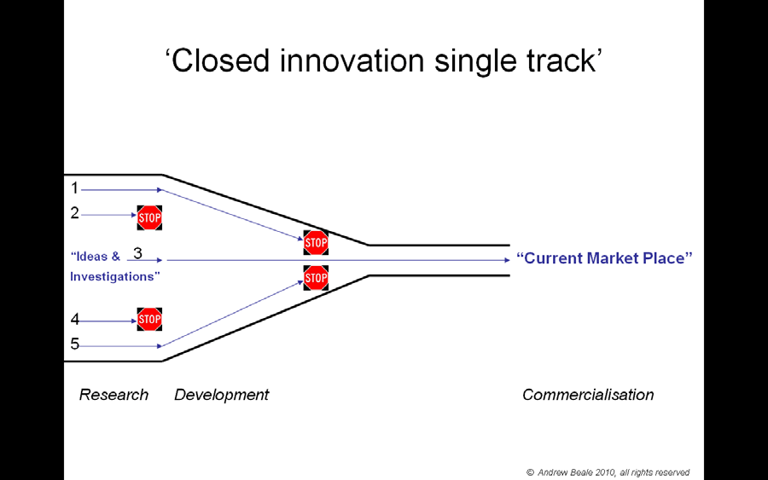

• When considered in isolation investigation (1) above is stopped at the development stage as lacking commercial merit.
• When considered in isolation idea (2) above is stopped at the research stage as lacking commercial merit.
• Innovation (3) above progresses through research and development to commercialization within the current market place.
• Idea (4) above is stopped at the research stage as lacking commercial application within the current market place.
• Investigation (5) above is stopped at the development stage as lacking commercial application within the current market place.

‘Open Innovation Highway’
In his Reith Lectures 2005 Lord Broers made clear that, “the domination of the large industrial research laboratory has largely come to an end.” The controlled environment of the corporate laboratory is in marked contrast to today’s free and easy access to an enormous wealth of worldwide R&D information across technology disciplines, such that it has become increasingly unrealistic for any one organization to believe that it should continue to compete in the market place by doing everything internally. At the same time the growth of the global market has meant that firms are faced with the increased cost of maintaining a much larger portfolio of registered intellectual property rights, leading to venture capitalist and shareholder demands to extract added value from these Intellectual Assets.

© Andrew Beale (2010), all rights reserved
In 2003 Professor Henry Chesbrough observed that some large American companies were becoming far more open to the idea of both licensing-in technologies from outside the company and licensing-out company technologies to others. This ‘open’ model of innovation is represented below:-

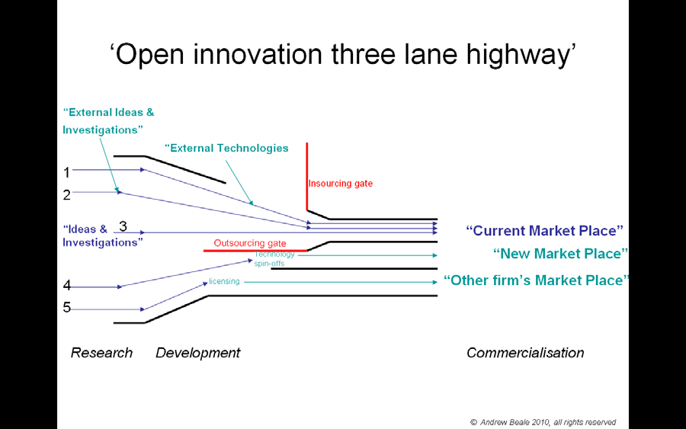

• In-sourcing of complementary external technologies enables investigation (1) above to progress through research and development to commercialization within the current market place.
• In-sourcing of complementary external ideas enables idea (2) above to progress through research and development to commercialization within the current market place.
• Innovation (3) above progresses through research and development to commercialization within the current market place.
• Idea (4) above is progressed through research and development to a new technology spin-off company for commercialization within a new market place.
• Investigation (5) above is progressed through research and development to be licensed to an external firm with a complementary commercialization strategy.

This new ‘open’ model of innovation is founded upon the premise that it is commercially more important to build a better business model than get to the market place first. Whilst this new model allows firms to tap into a vast talent pool

© Andrew Beale (2010), all rights reserved
beyond the company it also recognises that external ideas can only help to create value for the company if they are captured by internal R&D.

Commercial Opportunity?
mSMEs are important to the economies of all nations – they constitute some
90% of all enterprises worldwide and account for more than 70% of the production of goods and services.

The commercial opportunities presented to mSMEs as larger companies move towards this more ‘open’ model of innovation are significant. It has been said that nobody experiences the rebuttal of the unsolicited enquiry more than the mSME. Yet this newly adopted more ‘open’ model of innovation frees larger corporations to both license out their technologies to mSMEs and licence in mSME technologies under more versatile collaborative innovation arrangements.

Consider for example the Proctor & Gamble Connect+ Development Programme under which the company is pledged to source innovations from external sources and offer up for license granted patents if they remain unused by the company.

IP Wales experience:

• It is often easier in the first instance for the mSME to ‘pitch’ its approach to a large company as looking to ‘buy’ a technology need to complement an existing mSME technology rather than trying to ‘sell’ a technology solution to the large company.

In making an approach to a target company it is important to first understand the
‘technology roadmap’ being used by that company to scout for potential solutions to their company needs and outsource their company assets. But any potential partnering arrangement is likely to include more than just technology fit and it is important to ensure that your commercialization strategies complement each other. In order to achieve this you need to have set a clear strategic direction for your own business.

© Andrew Beale (2010), all rights reserved

